Four Principles for Document Accessibility – Windows Version
By adhering to these four principles, Word documents and documents saved from Word to PDF will be accessible. Note: The instructions below apply to Microsoft Word 2010 / 2013 for Windows.
- Provide heading structure
- Provide alternative text for images
- Provide self-describing links
- Provide accessible lists

Heading Structure
- Highlight the text that you would like to make a heading.
- Click the Home tab.
- In the Styles pane, click the heading level you would like to apply to the text.
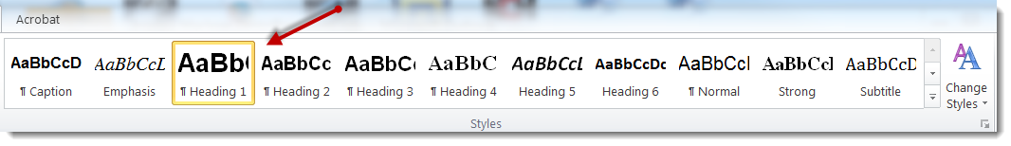

Things to consider when creating heading structure:
- The heading structure should outline the document. For example, the document title would be Heading 1, individual sections would be Heading 2, subsections would be Heading 3, etc.
- You may change the appearance of the headings by right-clicking a particular heading style (example: Heading 1) and selecting “Modify Style.”

Alternative Text for Images
- Right-click on the image.
- Select Format Picture.
- In the dialog box that appears, select Alt Text.
- Enter the alternative text for the image in both the Title and the Description fields. Describe the meaning or purpose of the image in its context rather than its appearance.
- Click OK to save your changes.
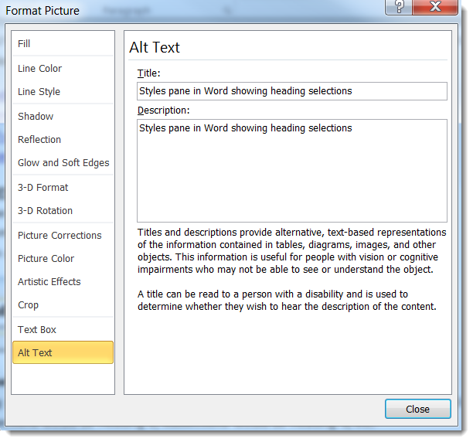

Things to consider when providing ALT Tags for images:
- You do not need to include “image of” or “picture of” in the description. For example: “University of Montana Clock tower” instead of “Picture of University of Montana Clock tower”.
- Any text within the image must be included in the Alt Tag.
- Clickable images must describe the function, not the image. Example: a picture of a house that takes the user to the Home Page when clicked should be tagged “Return to Home Page” and not “House.”
- Keep Alt Tags short (less than a paragraph). For a longer description, include it near the image as standard text.
- In Word, all images must be ALT tagged, even if they are purely decorative.

Self-Describing Links
- Highlight the text you would like to make the link.
- Right-click the text or go to the Insert tab and click on Hyperlink.
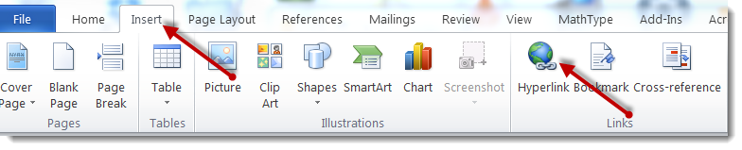
- Type or paste the URL in the Address field.
- Press OK.

Things to consider when providing self-describing links:
- The link text should describe where the user will be taken. For example: University of Montana Homepage
- If you wish to include the URL for users who may print the document, place the URL in parenthesis next to the self-describing link, right-click the URL, and select Remove Hyperlink. Example: University of Montana Homepage (http://www.umt.edu)

Accessible Lists
- Select the items you would like to make into a list.
- Click the Home tab.
- Press either the Ordered List (123/ABC) or Unordered List (bullets/dashes) button in the Paragraph pane.
- Select the desired list type.
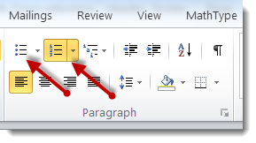

Things to consider when providing accessible lists:
- Word usually can predict when you are building a list. If Word automatically places the next item indicator (numbers, bullets, dashes), then the list will be accessible.
- Use lists in lieu of tables whenever possible.

The following are other important accessibility principles to keep in mind:
- Ensure that font size is sufficient, usually around 10 – 12 points or more.
- Provide sufficient contrast between text and background color. Use a Color Contrast Checker when in doubt.
- Do not use color alone to convey information.

